**FRONT-END**

1. Product Registration Page

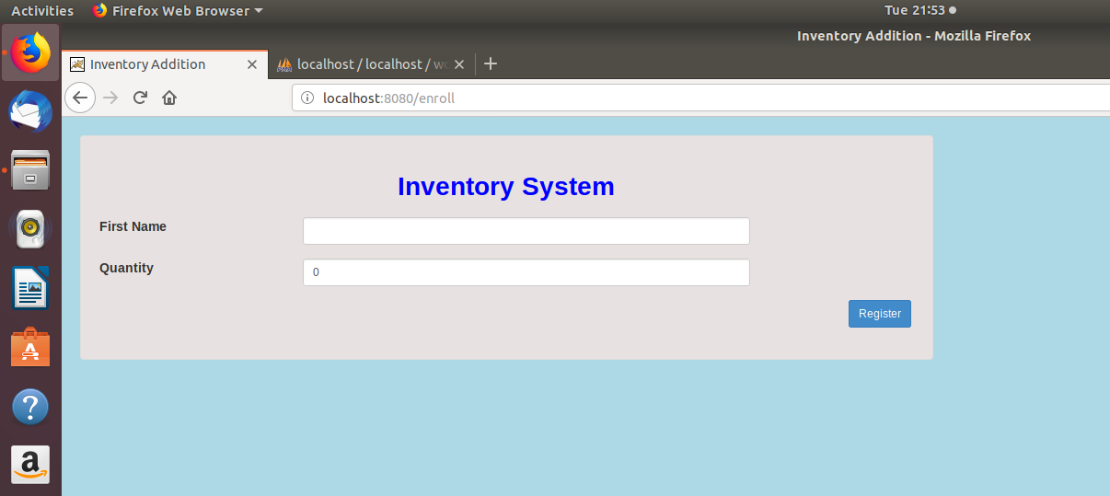

1. Inventory List Page

Features: Page No. wise display result content, capability to delete inventory data

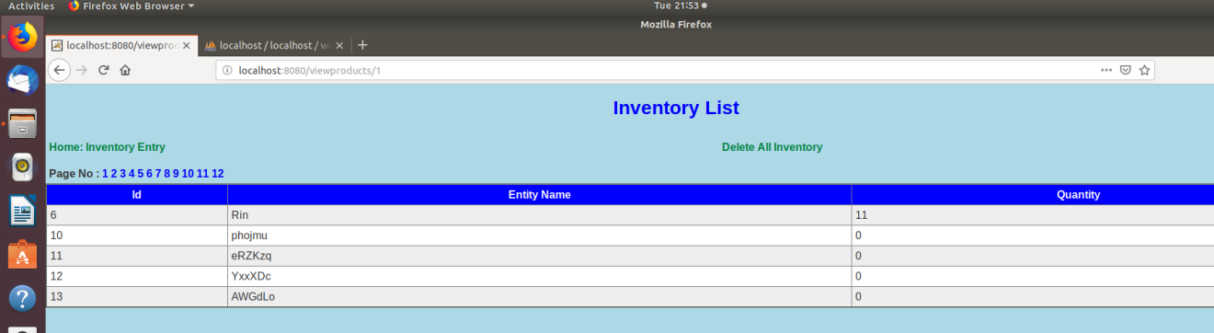

**API**

1. Returns all the List of Products in JSON Format

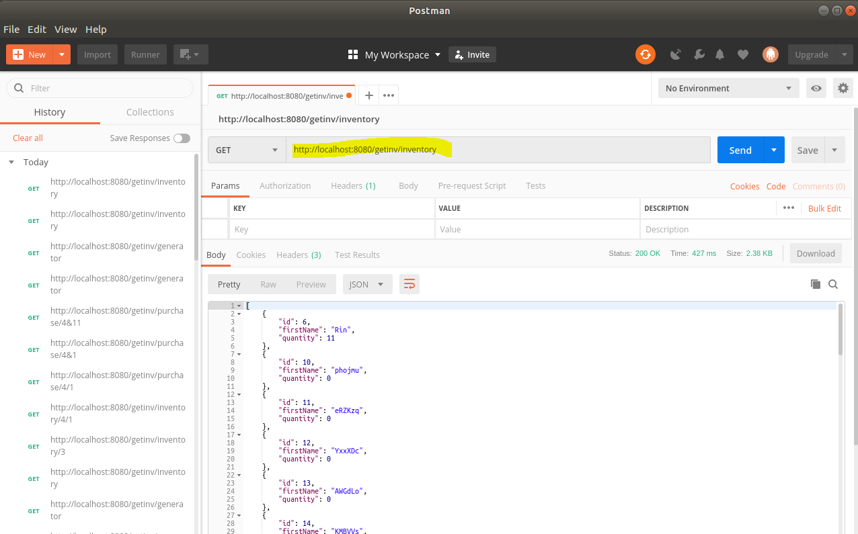

1. Returns List of Products on basis of “Page No” in JSON Format

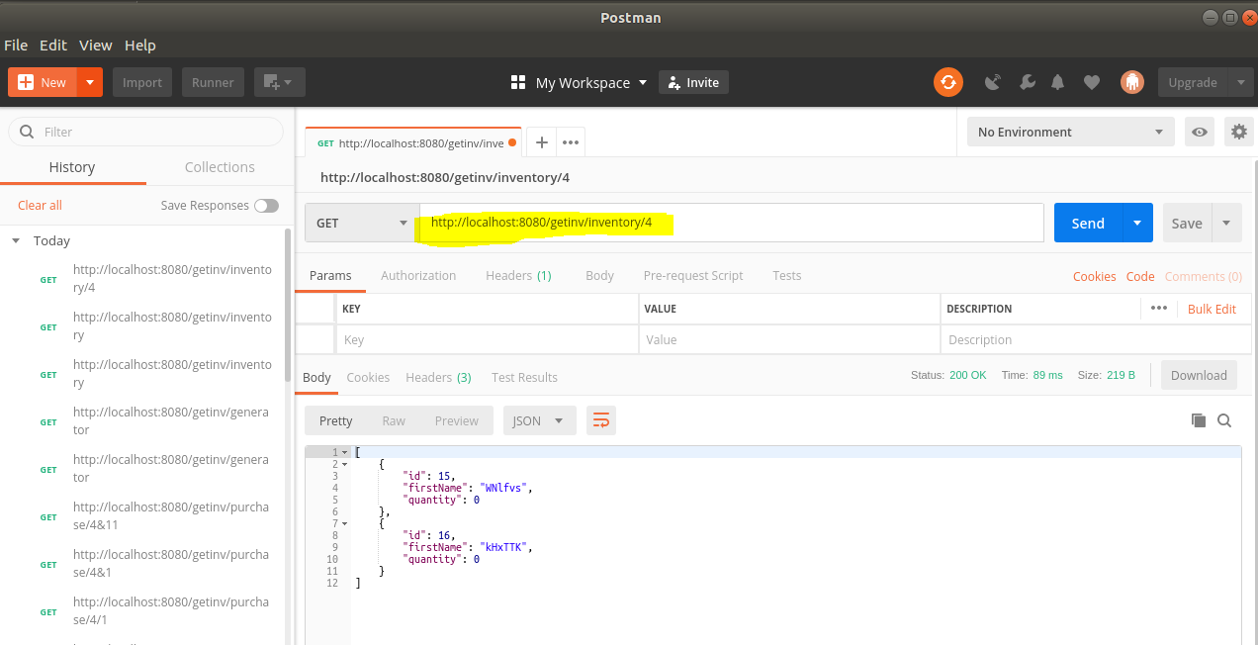

1. Purchasing of product can be done by passing 2 parameters(Id and Quantity)

If the product will not have enough quantity it will be removed from the database.

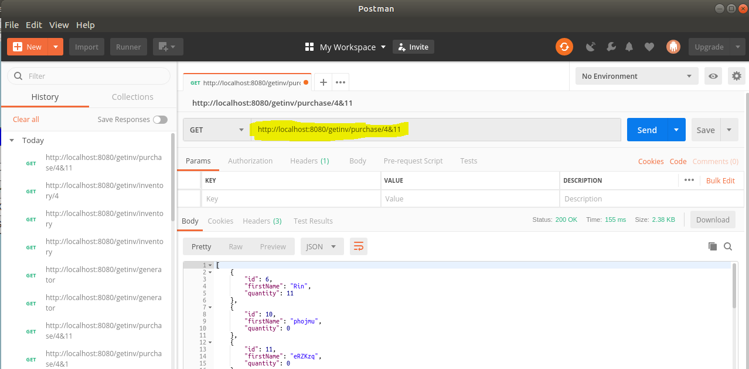

1. Generator api: It will add products into the database in every 1 sec by generating random names and Quantity



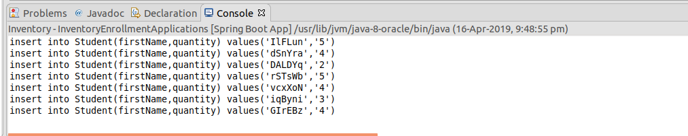

Database: ‘id’ is the Primary Key, ‘firstName’ is Product Name and ‘quantity’ is Product Quantity.

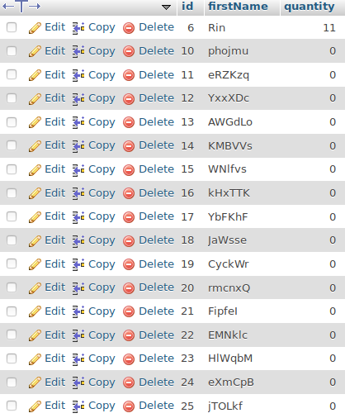

**About Project:**

Framework used: Spring Boot

Language used: Java

Database used: MySql

Other Software used: POSTMAN for API Request